Derek McCrea March 2008 Artist Newsletter

Hello all. This has been a fairly slow month with my art, but I did happen to complete
several new large tropical florals I have included below. And 15 of my works are available
on tile at a link below also.

Hibiscus
15 x 20 inches
Original Watercolor Painting
http://www.derekmccrea.50megs.com/photo.html

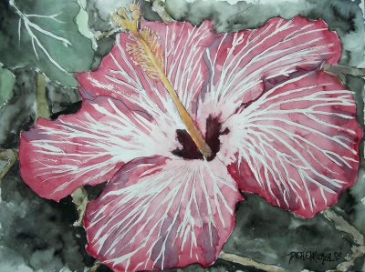

Umbrella Tree with Fruit
15 x 20 inches
Original Watercolor Painting
http://www.derekmccrea.50megs.com/photo.html

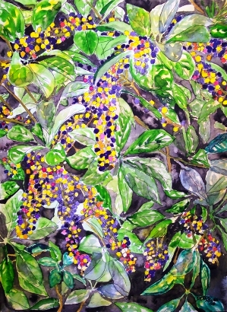
Along with creating the above new tropical watercolors view 15 of my works on tile,
backsplashes for kitchens, and bathroom tile, customizable to different sizes and
texture where I am currently the featured artist at:

http://www.tilebydesign.net/products.asp?cat=103

Until next month, I will do my best to keep creating. The next hurdle is to master the skill on Yupo Paper.

Art by Derek McCrea
http://www.derekmccrea.50megs.com

